 

**COLLEGE CODE : 3125**

**COLLEGE NAME : TJ INSTITUTE OF TECHNOLOGY DEPARTMENT : B.Tech AI & DS**

**STUDENT NM-ID : eec023c80dcc1c6bd2044a0786d3a071 ROLL NO : 31252324301**

**DATE : 17 / 05 / 2025**

**Completed the project named as Autonomous Vehicles and Robotics SUBMITTED BY,**

**NAME : S.VIJAY PRABHAKAR**

**MOBILE NO : 9688928251**

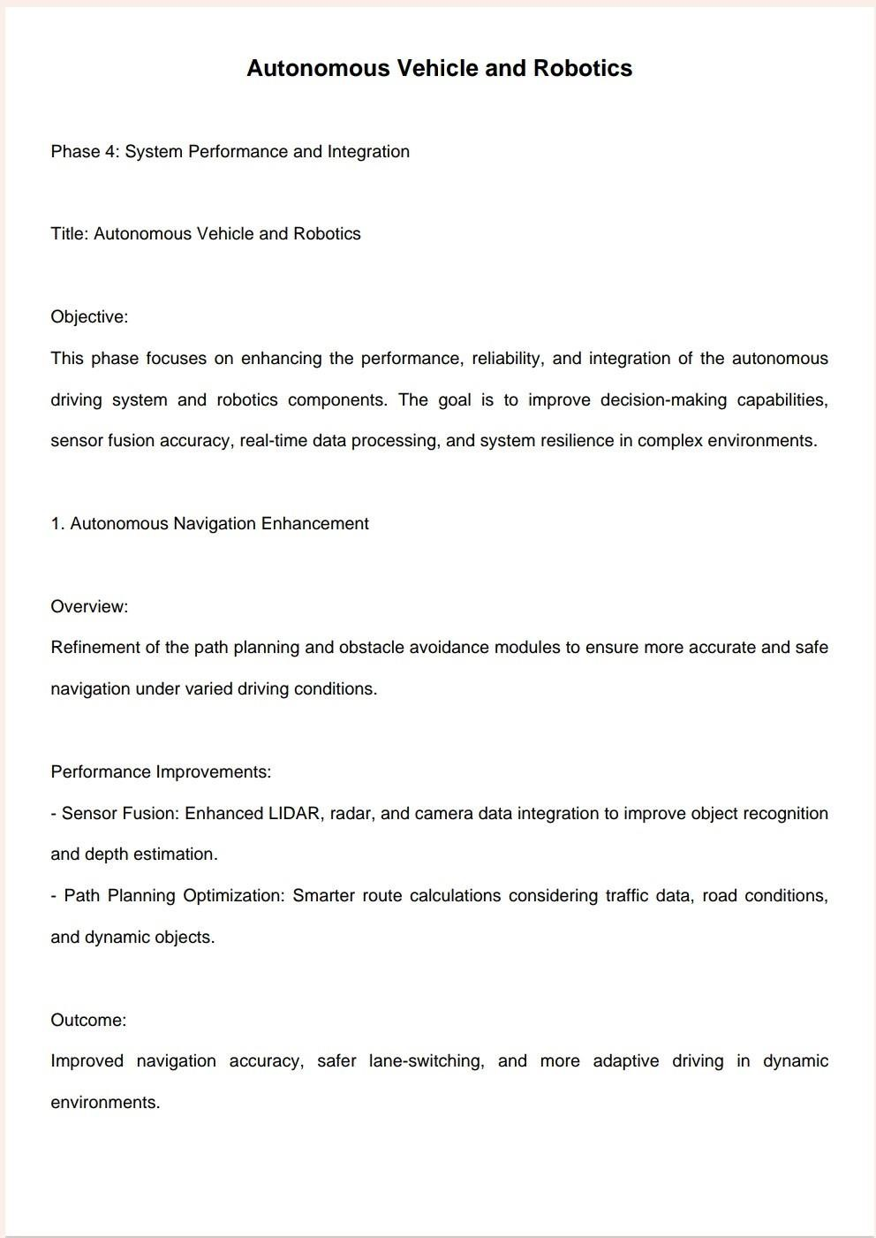

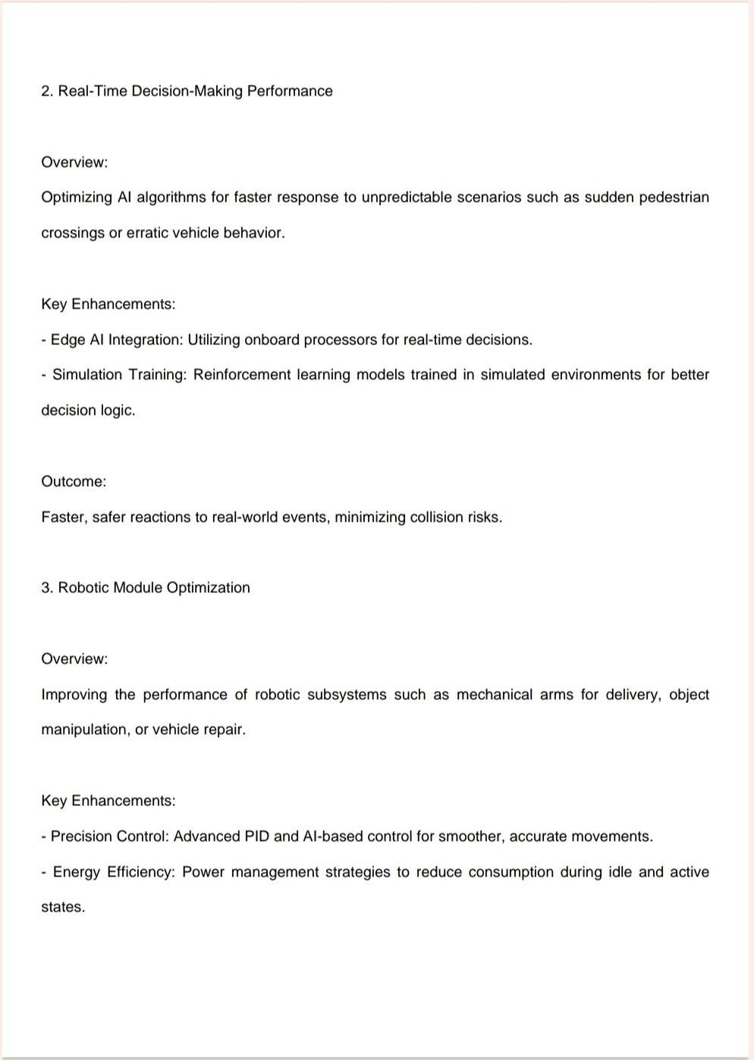

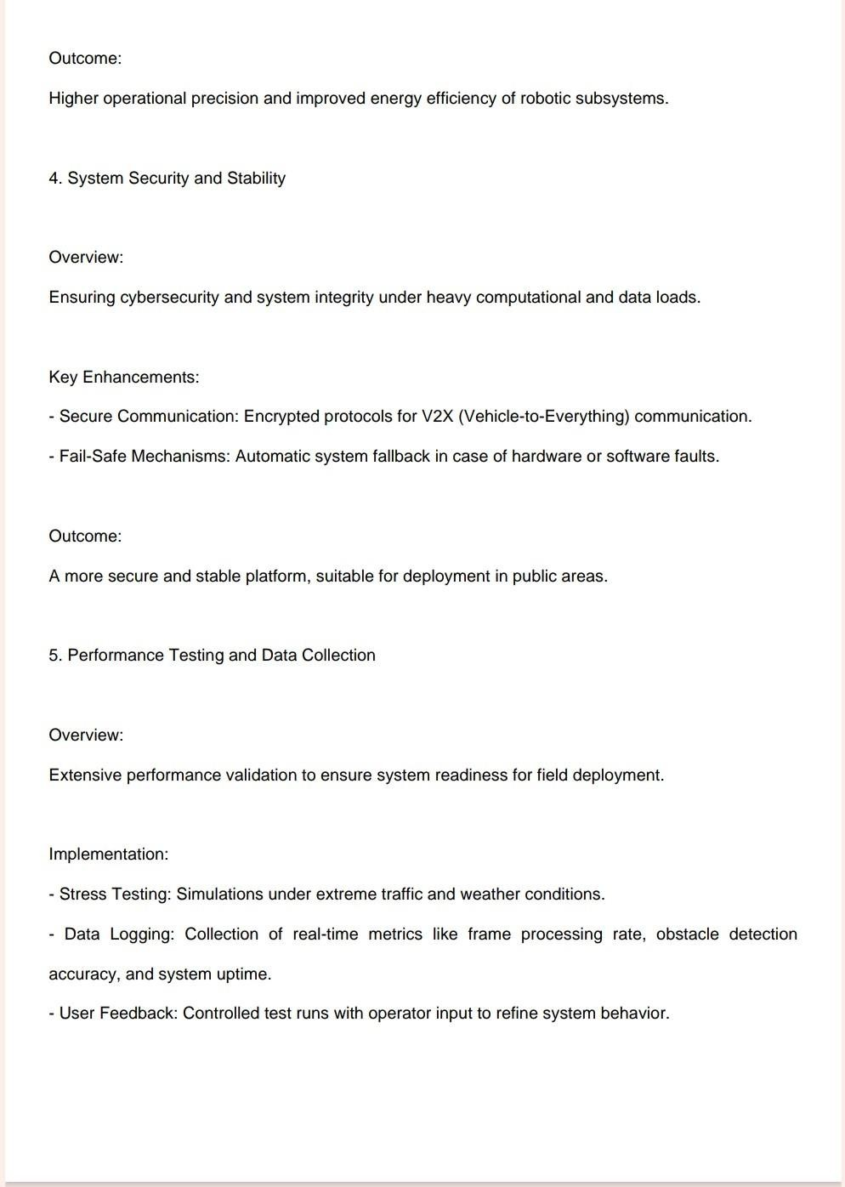

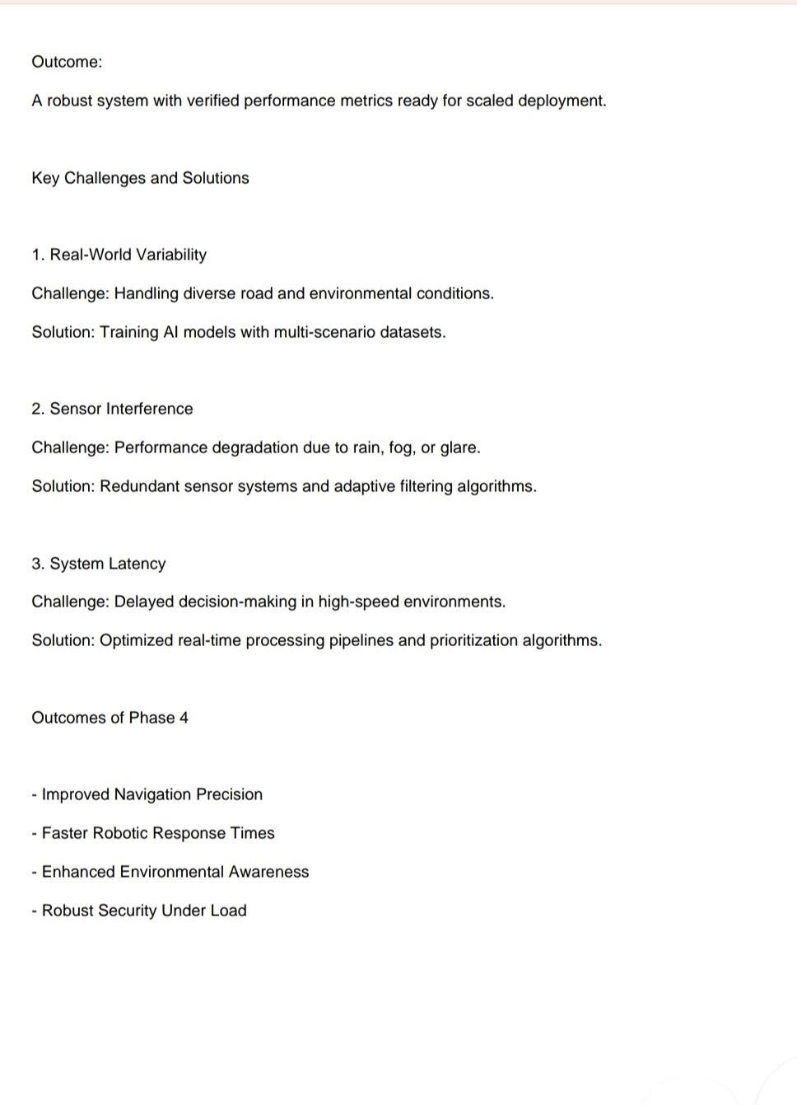

Page 1: Source Code

import pandas as pd import

matplotlib.pyplot as plt

# Load CSV

df = pd.read_csv("your_file.csv")

# Sample first 10 rows for

visualization sample_df = df.head(10)

# Create subplots

fig, (ax1, ax2) = plt.subplots(2, 1, figsize=(10, 10))

# Bar chart: Date vs Volume

ax1.bar(sample_df['date'], sample_df['volume'], color='red') ax1.set_title('Bar Chart: Volume

Over Time')

ax1.set_xlabel('Date')

ax1.set_ylabel('Volume') ax1.tick_params(axis='x', rotation=45)

# Scatter plot: Open vs Close

ax2.scatter(sample_df['open'], sample_df['close'], color='blue')

ax2.set_title('Scatter Plot: Open vs Close Prices') ax2.set_xlabel('Open Price')

ax2.set_ylabel('Close Price')

plt.tight_layout() plt.show()



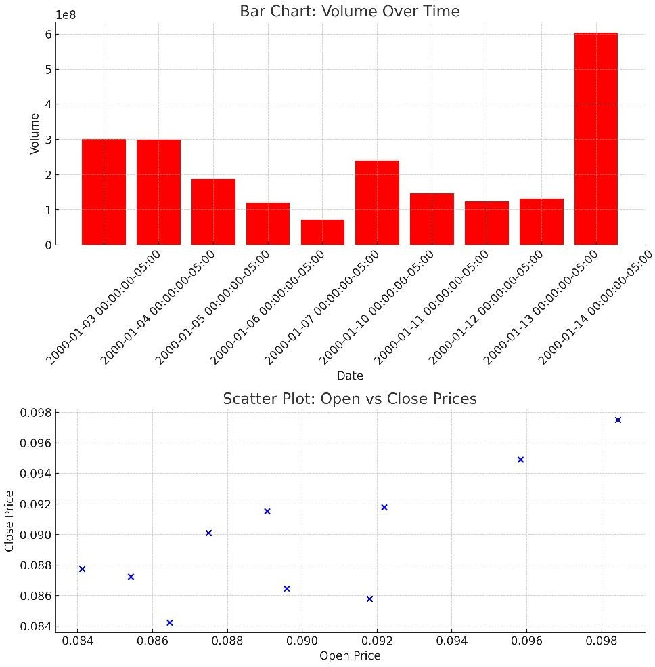

The bar chart is displayed in red and shows volume over time. The scatter plot compares open and close prices.



To run the above code and generate the plots, the following software and packages are required:

1. Python 3.x
2. pandas
3. matplotlib
4. Jupyter Notebook or any Python IDE
5. CSV file containing the required data (with columns: date, open, close, volume, etc.)

Optional:

- Microsoft Word or compatible software to view the document.